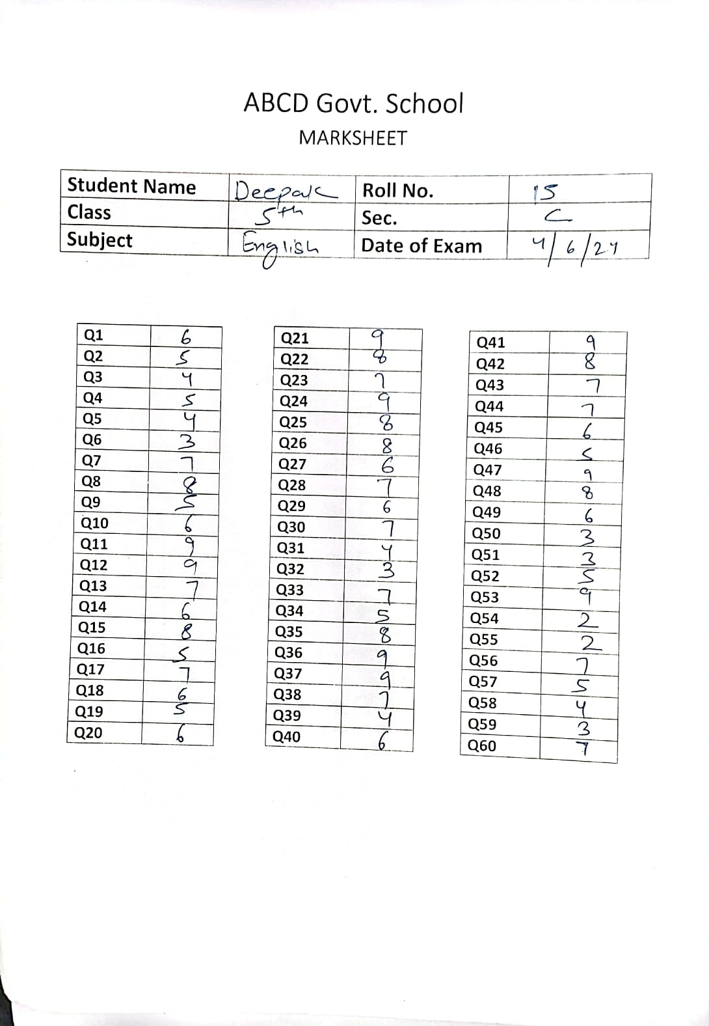

|  |  |  |  |  |  |  |  |
| --- | --- | --- | --- | --- | --- | --- | --- |
| Q1 | 6 | Q16 | 5 | Q31 | 4 | Q46 | 5 |
| Q2 | 5 | Q17 | 7 | Q32 | 3 | Q47 | 9 |
| Q3 | 4 | Q18 | 6 | Q33 | 7 | Q48 | 8 |
| Q4 | 5 | Q19 | 5 | Q34 | 5 | Q49 | 6 |
| Q5 | 4 | Q20 | 6 | Q35 | 8 | Q50 | 3 |
| Q6 | 3 | Q21 | 9 | Q36 | 9 | Q51 | 3 |
| Q7 | 7 | Q22 | 8 | Q37 | 9 | Q52 | 5 |
| Q8 | 8 | Q23 | 7 | Q38 | 7 | Q53 | 9 |
| Q9 | 5 | Q24 | 9 | Q39 | 4 | Q54 | 2 |
| Q10 | 6 | Q25 | 8 | Q40 | 6 | Q55 | 2 |
| Q11 | 9 | Q26 | 8 | Q41 | 9 | Q56 | 7 |
| Q12 | 9 | Q27 | 6 | Q42 | 8 | Q57 | 5 |
| Q13 | 7 | Q28 | 7 | Q43 | 7 | Q58 | 4 |
| Q14 | 6 | Q29 | 6 | Q44 | 7 | Q59 | 3 |
| Q15 | 8 | Q30 | 7 | Q45 | 6 | Q60 | 7 |